## Experiment No. : 1

**Title:** Install and configure SQL Server Business Intelligence edition

**Objectives**: 1. To Plan SQL Server Business Intelligence edition Installation

2. To Install Prerequiste Softwares for SQL Server BI

3. To Install SQL Server Business Intelligence

4. To Configure SQL Server Business Intelligence

**Key concepts:** Install, Configure

Theory:

What is business intelligence (BI)?

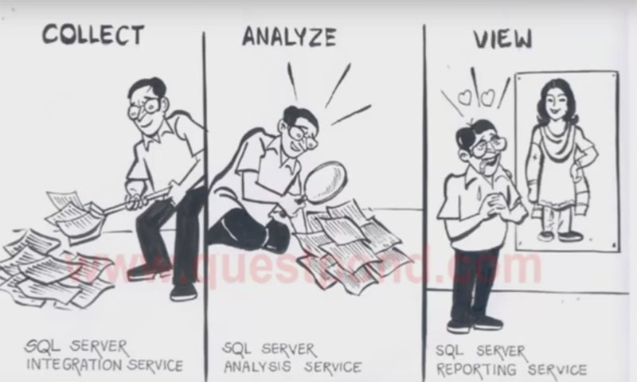

Business Intelligence (BI) is a set of techniques and tools for converting raw data into meaningful and useful information.

BI is a technology-driven term refer to as software-application used for organizations to integrate, analyse and present raw data to help organizations to make more informed business decisions and strategic planning.

In simple words Business Intelligence is nothing but converting data into information and that information used to make better strategic planning and decision.

For example : Let's take up an example of world's largest chain of hamburger fast food restaurants McDonald's. McDonald's as we all familiar with this restaurant. It has several restaurant chain across India and also across the world. BI is very useful tool for these kind of companies who has branches across country. BI tool will be useful for McDonald company to make strategic decision on to add / remove menus, dishes depending on location. McDonald is restaurant chain business and to have centralized BI system will help them run their businesses smoothly and make accurate decisions. It not only help to make strategic decision but also can measure the performance of each store in each location.

Companies who uses this BI tool can improve decision making power, understand strength and identify new business opportunities. Today's fast moving pace an organization should evolve according to trend. So to understand trend company should understand overall progress its products.

What is Microsoft business intelligence (MSBI)?

Microsoft has created powerful suite, comprises set of tools which helps in providing best solutions for Business Intelligence. Microsoft + Business Intelligence called as MSBI (Microsoft Business Intelligence). MSBI is a part of SQL Server which uses part of SharePoint services. In SQL Server data tool there are other different tools available for different processes as needed for BI solutions.

Note : This MSBI Visual Studio Data tool comes with SQL Server. This data tool we need to download separately that we will see in below part of an article.

MSBI categorized in 3 parts available in SQL Server Data Tool.

These 3 steps are useful in performining business intelligence activity.

SSIS - Integration tool - (SQL Server Integration Services).

SSAS - Analytical Tool / Analysis tool - (SQL Server Analytical Services).

SSRS - Reporting tool / Data View Tool - (SQL Server Reporting Services).

What is SQL Server Integration Services (SSIS) ?

Microsoft's SQL Server Integration Service tool (SSIS). SSIS is useful in collecting information / data in different formats from various locations and gathering it to the centralized location. It performs three important task "Extraction", "Transformation" and "Loading".It is an enterprise tool for data integration, data transformation and data migration.

For Example : Lets say we have different data in various formats (XML, EXCEL). First we to extract all data from these formats and we will add to our "TXT" file for transforming into single format, while adding we will transform data according to the way we want. Here in this case i will say "UPPERCASE" transformation then finally loading to our centralized database i.e. "SQL Server".

What is SQL Server Analysis Services (SSAS) ?

SSAS is the second step after SSIS, To analyze the centralized stored data we need to use SQL Server Analysis Services. Analysis service uses OLAP (Online Analytical Processing) component of MS SQL Server and data mining capabilities. SSAS helps to create OLAP CUBES (multi-dimensional array of data) using data from data warehouse and also to build mining models for deeper and faster analysis.

For Example : If you want to know exact performance of a particular outlet of McDonald then this OLAP analysis service will help you identify valuable information like dislikes, most sellings, customer visits etc.

This is all about SSAS now let's move on to third and final step of BI i.e. SSRS.

What is SQL Server Reporting Services (SSRS) ?

SQL Server Reporting Services (SSRS) is a graphical generating software system from Microsoft. After analyzing data properly as we saw in second step [SSAS] now its time to present data graphically in our final step [SSRS]. Graphically presented data is necessary for an organization to make an effective decision. Use of SSRS tool develop, design, test, and generate reports.

For Example : If a CEO of McDonald want to see exact performance of a particular outlet in Mumbai then SSRS graphical reporting system will help him easily to understand easily. Because data / information which is presented after deeper analysing.

Best part of SSRS is it comes with web-Interface with many tools and controls as a developer i prefer SSRS over crystal reporting because it is more stable and reliable and which uses an XML-based report file format. If you want to mail reports then you can also schedule them for delivery over e-mail.

SQL Server Installation and Configuration Steps

Download SQL Server from [https://www.microsoft.com/en-us/ download/ details.aspx? id=29066](https://www.microsoft.com/en-us/%20download/%20details.aspx?%20id=29066)

**Step 1:**Open installation media in new window and right click on setup file to run it “**As Administrator**”.  
  
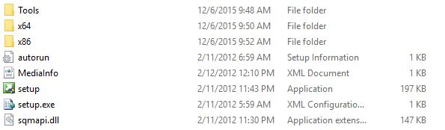  
  
**Step 2:** Installation Center  
  
After running the setup file, you’ll be redirected to Installation Media Center where you find various options. As we’re working on the installation, we won’t dig other parts. Click on **Installation**section and you’ll find something like the following window.  
  
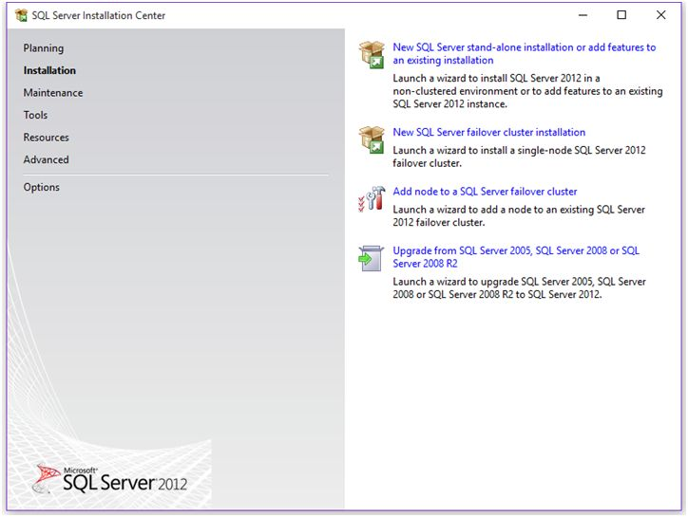  
  
From here, you can perform stand-alone installation of SQL Server or you can add any additional features to installed instances of SQL Server. Also if you want to upgrade you version of SQL Server, there’s an option for that as well.  
  
As we want to perform stand-alone installation, we’ll go with option 1. Click on the first link and the installation process begin.  
  
**Step 3:**Setup Support Rules  
  
Before proceeding with the installation steps, SQL Server setup runs a setup to check all the things required for installation. This check is nothing but a kind of verification to ensure you can proceed further or not.  
  
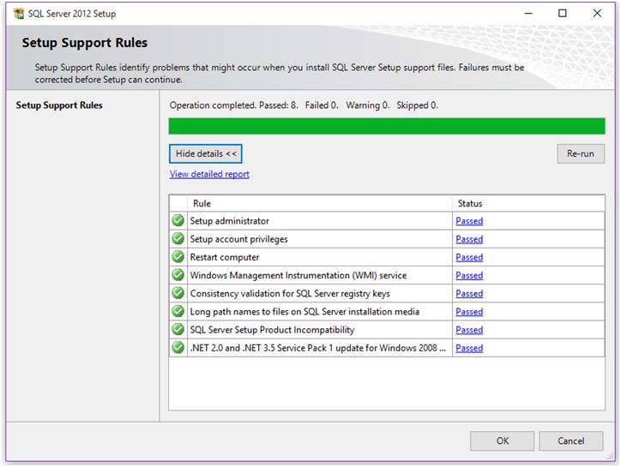  
  
If any of the check fails, you’ll get a failed notification in status column and you won’t be able to proceed further with the installation. If all requirements fulfill, you’ll get passed in Status column. Click OK.  
  
**Step 4:** Product Key  
  
Select edition of SQL Server you want to install on your machine with your product key and click Next.  
  
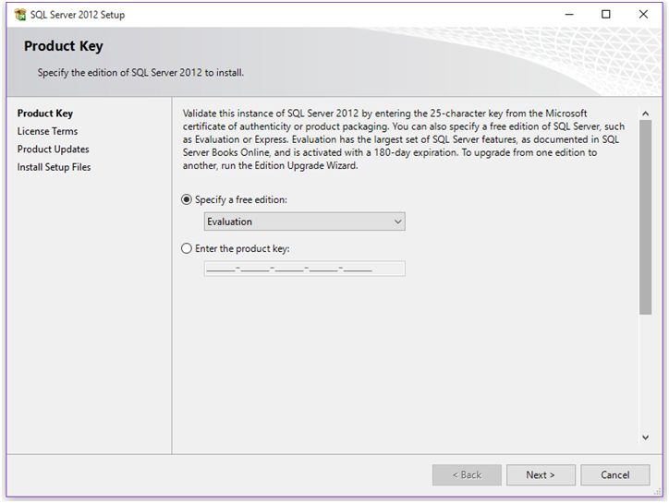  
  
**Step 5:** License Term

Accept the license by clicking on “I accept license terms.” Click Next.  
  
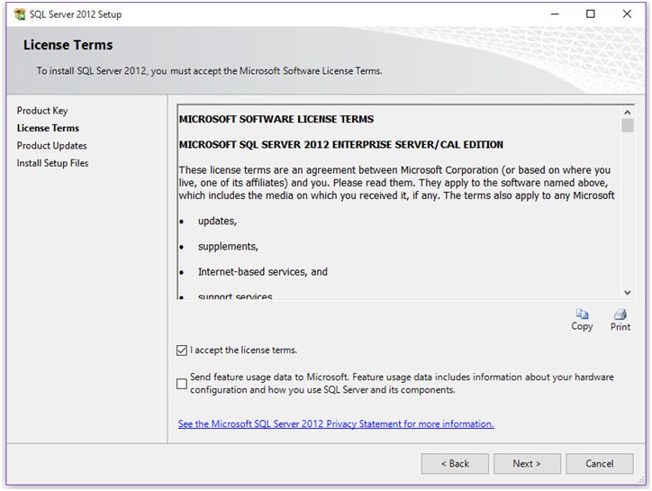  
  
**Step 6:** Product Updates  
  
Here, setup will look for latest product updates to enhance SQL Server performance as my setup found one update of 22 MB for enhancement as shown below.  
  
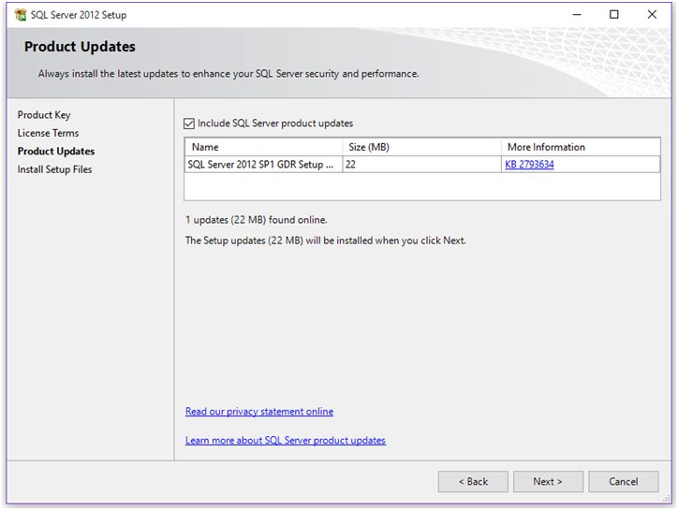  
  
**Step 7:** Install Setup Files  
  
At this window, you’ll get **Install**button to install the updates.  
  
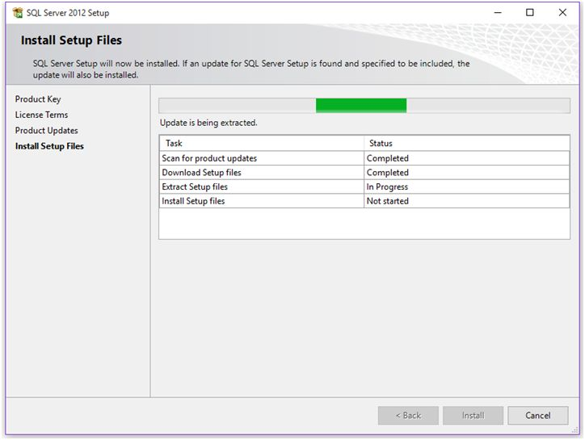  
  
**Step 8:**Setup Support Rules  
  
After successful completion of previous step, setup will again run a check to ensure everything looks good for the installation.  
  
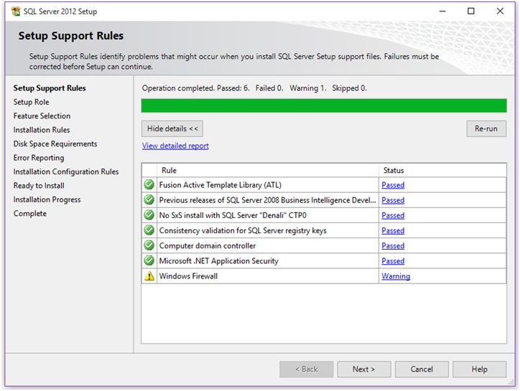  
  
**Step 9:** Setup Role  
  
At this step, you’ll find options like install SQL Server instance or install instance of Analysis Service with SharePoint integration. By default it’ll select ‘**SQL Server Feature Installation**’.  
  
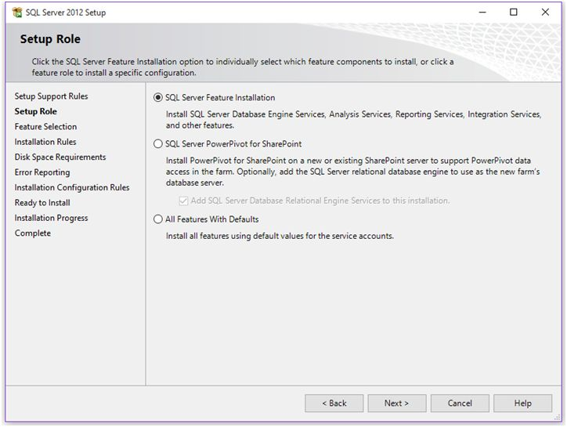  
  
If you select “**All Features with Default**”, the following things will be set by default:

* **On the Feature Selection page**, all features will be selected by default.
* **On Server Configuration page**, default accounts will be set.
* **On Database Engine Configuration page**, your current logon account will be added as a Server Administrator.

**Step 10:**Components or Features to Install  
  
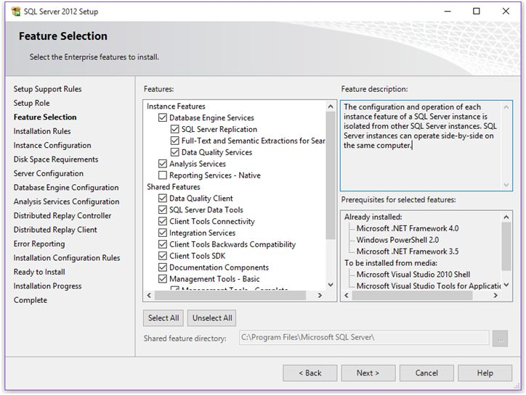  
  
Select the components you want to install on your machine. The following is the description for above listed components.

* **Database Engine Services:** Allow you to install SQL Server instance.
* **Analysis Services:**Allow you to install an Analysis Services instance on standalone or on cluster node.
* **Reporting Services:**Allow you to install the server as report server.
* **SQL Server Data Tool:**Allow you to install SQL Server Developer tool to work with integration packages. In SQL Server 2008 installation you’ll find this service named as ‘Business Intelligence Development Studio’.
* **Integration Services:** Allow you to install Integration Services.
* **Management Tool:**Allow you to install SQL Server management configuration tool including command line and power shell tool.

If you selected “**All Features with Default**” in previous step, all these components will be checked automatically.  
  
**Step 11:**Installation Rules  
  
After selecting the features to install, setup again runs a check to ensure whether your machine’s configuration is compatible or not to proceed further.  
  
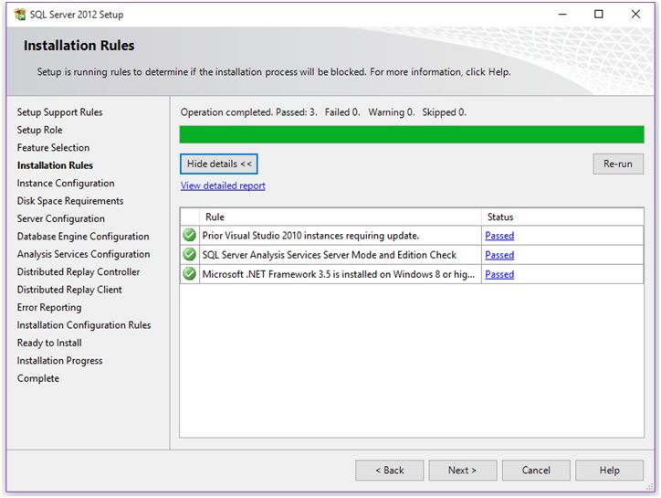  
  
If all looks good, click Next.  
  
**Step 12:** Instance Configuration  
  
This step will ask, what type of instance you want to configure, as we all know, either we can install Default or Named instance. If default instance is already installed, you’ll have to have proceeded with named instance.  
  
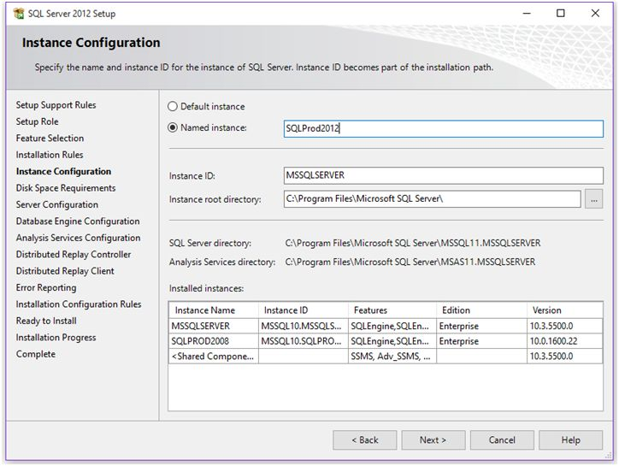  
  
Select type of instance you want to install. If you want to change the root directory of your instance, you can change it from ‘**Instance root directory**’ option. It’ll also show you the instance already installed on your machine. As shown in above screenshot, I already installed 2 instances on my machine.  
  
After doing instance configuration, click Next.  
  
**Step 13:**Disk Space requirement summary  
  
At this step, you’ll get disk space summary which will show how much disk space your instance will take on the machine.  
  
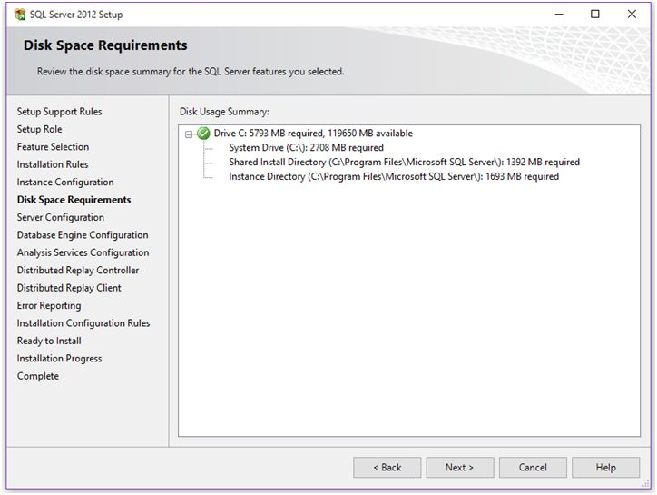  
  
**Step 14:** Server Configuration  
  
On this step you’ll find options to specify Service Accounts and Collation Configuration.  
  
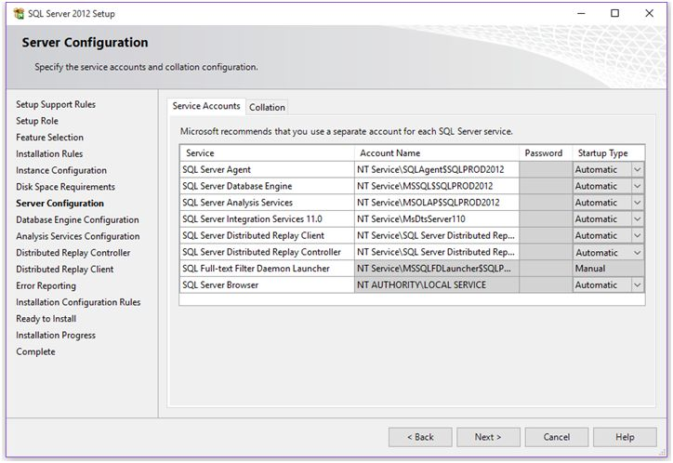  
  
Under **Service Account** tab, you’ll find option to set account name and password for any of the services; also you can choose start-up type of those services. You can set startup type as Manual or Automatic. It’s recommended to set Start-up type of SQL Services to Automatic.  
  
  
After performing above steps, click Next.  
  
**Step 15:** Database Engine Configuration  
  
This is the most important step because over here you’ll configure your servers configuration, data directories and file stream options.  
  
At**Server Configuration**tab, you’ll find authentication mode and SQL Server System Administrator [SA] account configuration.  
  
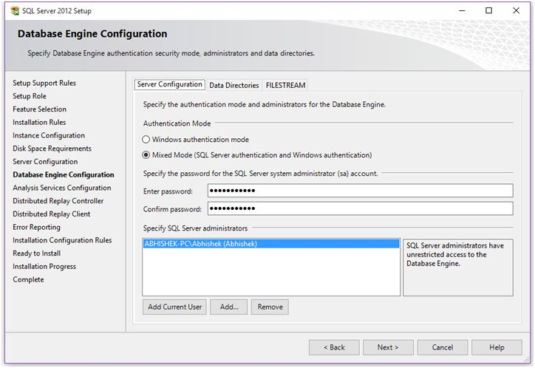  
  
If you see Data Directories tab, you’ll find your root directory, and location of below:

* Data root directory.
* User database directory,
* System database directory,
* User database log directory,
* Temp data and log directories, and
* Backup location

You can change these locations of your own choice.  
  
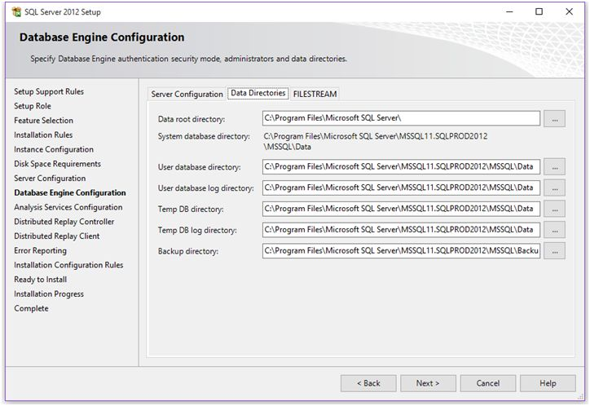  
  
  
  
After completing the steps, click Next.  
  
**Step 16:**Analysis Services Configuration  
  
If you had chosen Analysis Services to be installed on your machine, you’ll find this option during installation process.  
  
Complete this step by choosing server mode and adding **Analysis Services Administrator**.  
  
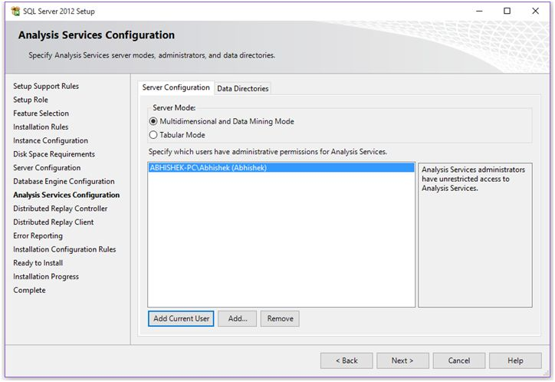  
  
Specify your Analysis Services data directories as shown below.  
  
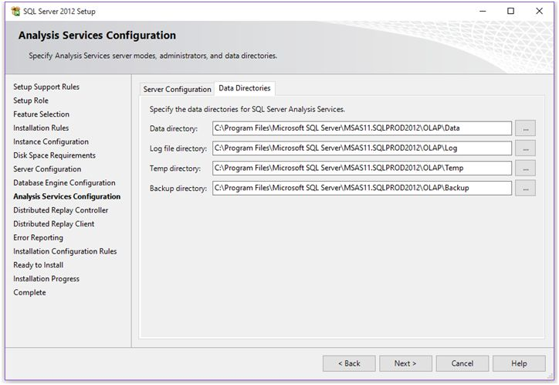  
  
Click Next,  
  
**Step 17:** Distributed Replay Controller  
  
If you had selected all shared features to install, you’ll get this and next step to complete.  
  
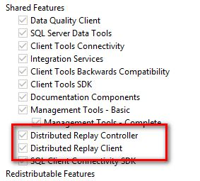  
  
At this step, you’ll find Distributed Replay Controller. This feature helps you assess the impact of future SQL Server upgrades.  
  
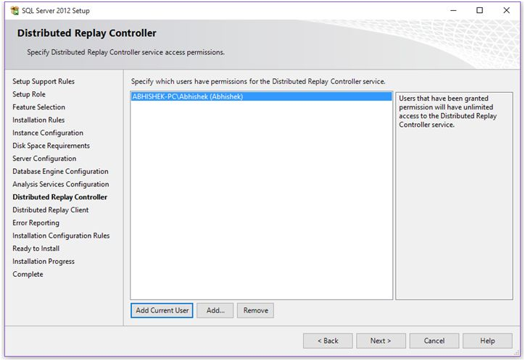  
  
This is similar to SQL Server Profile, Distributed Replay Controller replay a captured trace against an upgraded test environment. This feature can use multiple computers to replay trace data and simulate a mission-critical workload.  
  
Add users to have unlimited access to the Distributed Replay client service and click next.  
  
**Step 18:**Distributed Replay Client  
  
This is one of the component of Distributed Replay Controller under which one or more computers (physical or virtual) running the Windows service named SQL Server Distributed Replay client. The Distributed Replay client works together to simulate workloads against an instance of SQL Server.  
  
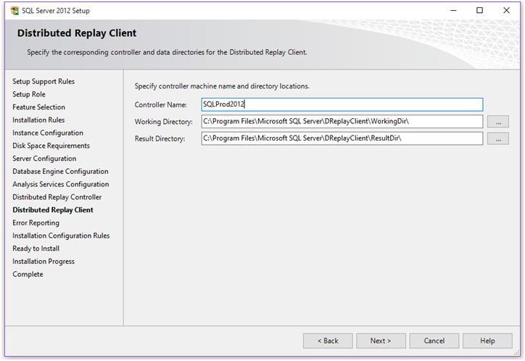  
  
Enter **Controller Name**so that the client computer will communicate with for the Distributed Replay Client Service. This is the optional parameter and the default value is ‘BLANK’.  
  
Specify the**working directory** for the Distributed Replay client service.  
Specify the**result directory** for the Distributed Replay client service.  
  
Click Next.  
  
**Step 19:**Error Reporting to Microsoft.  
  
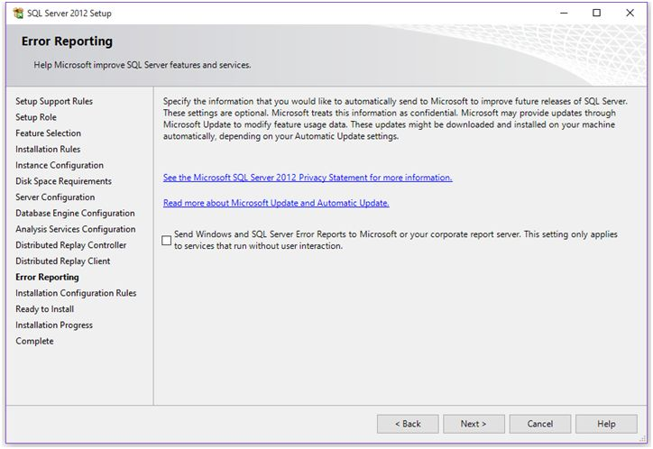  
  
Click Next.  
  
**Step 20:**Installation Configuration Rule  
  
At this step, setup will perform a final check to ensure everything looks good for installation operation.  
  
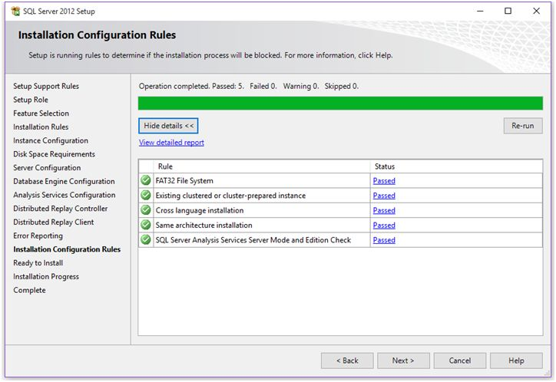  
  
If all rule passes, click Next.  
  
**Step 21:** Installation Summary  
  
Here you’ll get summary of your installation as shown below.  
  
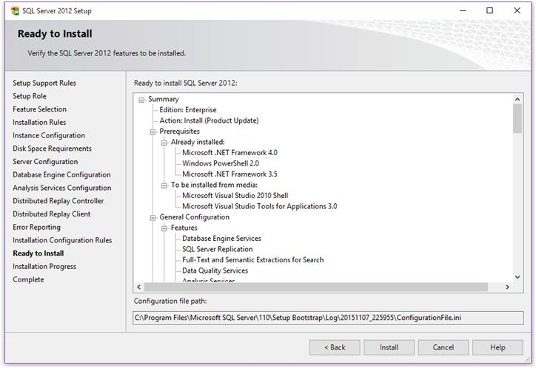  
  
If you’re satisfied with everything, click on **Install**button and you’re set to go.  
  
**Step 22:**Ready Steady Go!  
  
Installation process will start and you’ll see the progress as in the following,  
  
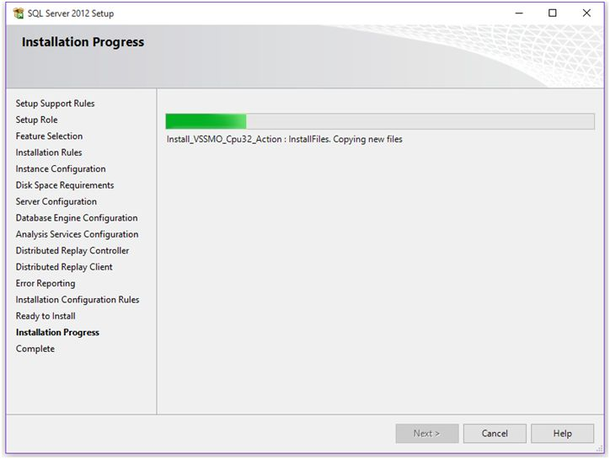  
  
This will take some time, relax and just watch the progress.  
  
**Step 23:**Installation completed  
  
After successful installation you’ll get the following window. This will show you the components installed on your machine with ‘Succeeded’ message in Status column.  
  
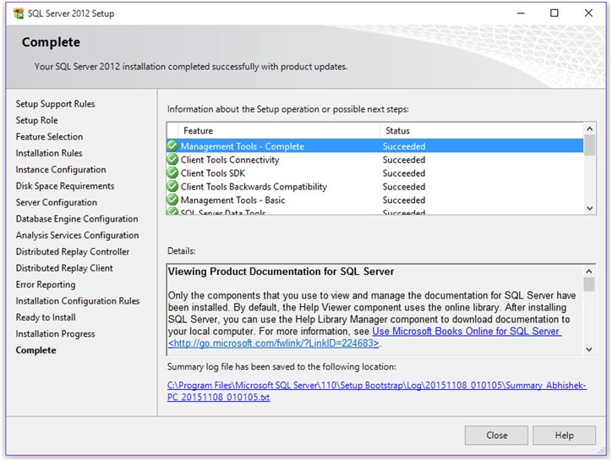  
  
Also you’ll get location of the log file of the complete installation.  
  
**Step 24:**Verification  
  
Open SSMS and connect your instance and you’re ready to explore.  
  
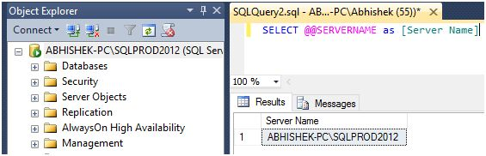  
  
**Conclusion**  
We’ve successfully installed SQL Server 2012 named instance on our machine. We have seen the steps involved in the installation.